Main Room
Room Booking Request Form
This form must be completed in full, failure to do so may results in this request being denied.
Calendar Invites - the following people MUST be invited for ALL bookings in these rooms
Phil Hughes pjh@aber.ac.uk & Theo Goree tcg1@aber.ac.uk | Technical setup & Bar Needs
Conference Office constaff@aber.ac.uk | Catering – please email requirements
esastaff@aber.ac.uk | Room Layout

Booking Deadline – 7 Days before event Date
Staff Member Taking Booking
Time and Date Booking Taken
Name of Event
Name of Event Organiser
Nature / Description of Event – Activities taking place
Name of Club / Society / Internal Department
Date of Event
Time (Start and End)
Access Required From
Room Vacated By * if after 10pm, see charges below in Bar opening times
Number of People Attending
Name of the person booking
Email
Phone number (and mobile)
Bookings will only be accepted by an official Students’ Union Club or Society, or a registered student at Aberystwyth University. We Will Cancel your booking if you have not supplied us with all of the information above.
Room Layout & Requirements
Room Layout Type (see below)
Numbers to be set up for
Room to be set up by (available from)
Furniture – Other – Please Specify
No. of tables available, Small round 20 – seat 4
Large Round 13 – seat up to 10
Trestle tables 20
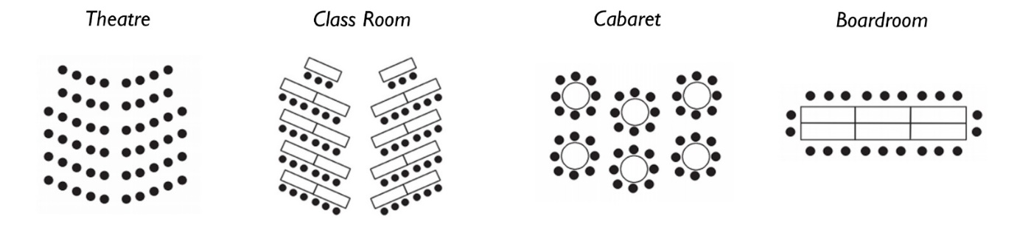
200 People 80 People 120 People 40 people

Bar required (from and until)  Standard Term-Time Bar Opening Times*  Mon – Fri 11:00 until 22:00  Saturday 11:00 until 22:00  Sunday 12:00 until 22:00 | Please note the standard opening times. *Outside of these there will be a service charge of £40.00 per hour to cover staff costs, payable in advance
Catering Requirement | Please email conference office at constaff@aber.ac.uk

Operation of Bar or Catering outlets outside of normal operating hours are by prior agreement only.

Additional items
Stage Units Required | To be agreed with the Phil/Theo in advance
Full Stage – 6 Pieces (W24ft x D12ft) / (W18ft x D16ft)
Single Units (8ft x 6ft)
Special Setup –
Steps – 3 Available - Free
Front of Stage Barriers - £15 for set up

Equipment Requirements – Basic Setup | Per Event
Microphone | £10.00
Location for Mic, stage end or DJ booth only
Provision to play music via 3.5mm (jack / iPod lead) | Free
Additional Microphones (max of 3) | £5.00 each

Equipment Requirements – Advanced | Per Event
CDJ – Pioneer CDJ 100 MK3 (2 available) | £25.00
Mixer – Pioneer DJM 900 NEXUS | £25.00
Access to Lighting Desk and disco lights. | Included with the above hire
Specify any special requirements or leads to be provided | These may be subject to additional cost subject to availability

Security/ Additional Staff Costs
For any setup of rooms past 5pm will have additional charges applied.
For any ticketed live or recorded music event in the Students’ Union, we have a legal obligation to have Security Industry Authority (SIA) registered staff present. This service is provided by an external Security Company at the rates below (November 2018) and payment must be made in advance directly to the Security Company to ensure the event goes ahead. For very large events where the bar takings exceed an average of £1k per hour for the entire duration of the event, or in exceptional other circumstances, this charge may be waived.

For all ticketed live and recorded music events

Minimum of 2 SIA staff required for any ticketed event  Additional SIA staff required depending on numbers | Cost £27.00 per hour of the event with an additional ½ hour set up and breakdown.  £13.50 per hour per person
Door sales attendant | £10.00 per hour (if required)
Cloakroom Attendant | £10.00 per hour – (if required)
Room Setup After 5pm | £19.05 per hour

Please note that any damage to equipment or building facilities caused during an event is at the liability of the event organizer and will be recharged accordingly on receipt of EDD invoices.

