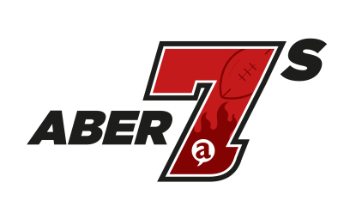
Aber7s : 5th – 6th May 2018

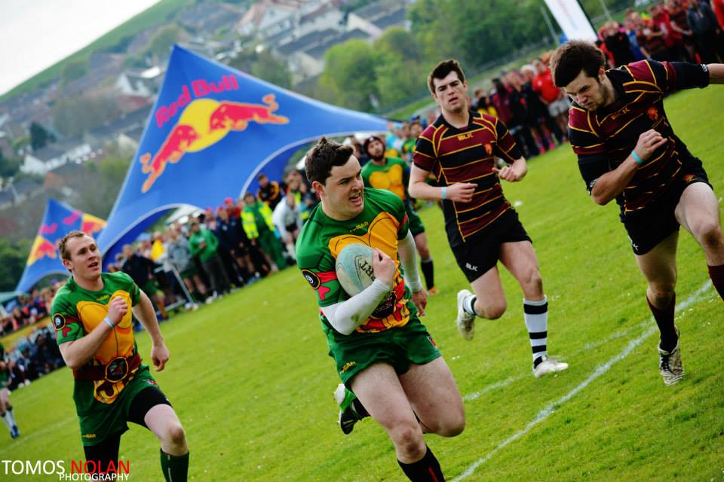

Approximate engagement: 1,500 students and 500 locals

The annual Aber7s Festival attracts over 1,000 rugby players & 1,000 spectators to one of the biggest rugby tournament in Wales bringing a small seaside town to life over May Day Bank Holiday weekend.

This year’s Aber7s promises to be the biggest yet; with a total number of 100 rugby teams and brand new social tag rugby competition. With your help, we can grow the event for the benefit of the students, the town and the whole community. Therefore, we kindly ask for your support to ensure the success of Aber7s 2018. Please take a look at the sponsorship packages and get in touch.

 | Competition | League | Pitch
Banner (200x80 cm) |  |  | (provided by sponsor)
Announcements on the day
Brand presence on Aber7s website
Social Media Post
Entry Passes to Aber7s | (up to 5) | (up to 2)
Present an award at the Ceremony
 | £300 +VAT | £150 +VAT | £100 +VAT

Key information
- Competitions: Men’s Premier, Men’s Intermediate, Men’s Social, Women’s Premier, Mixed Tag Rugby
- Date of the event: 5 & 6 May
- Deadline for booking: 1 February
- Deadline for artwork: 7 February

Booking Form

By booking you agree to the T&Cs in the AberSU Media Pack 2017 (available at abersu.co.uk/advertising/)

To book please fill in the details below.
Event
Package Chosen
Organisation
Contact Name
Address & Post Code
Contact Number
E-mail
I want to receive information about upcoming events and marketing opportunities provided by the Students’ Union. Your data will be used in accordance with Data Protection Act 1998 and stored for a period of 5 years. We will not share your data with 3rd parties. You can have your details deleted at any time by contacting us.

To honour the terms of the sponsorship, we will need payment before the event. Payment options:
cheque - payable to “Aberystwyth University Students’ Union”
BACS after receiving an invoice. Purchase Order: _________________
card over the phone: 01970 62 17 04
cash (date) _________________

