Officers Report
Ash Sturrock

Senedd
05/12/2022
Summary:

A lot has happened since our last Senedd meeting and I am pleased to say how successful this year has started out. We are returning to original numbers of engagement we had before Covid and its great to see how many students are getting involved in the union through campaigns, clubs and socs and academic representatives. We have has a couple student campaigns this year so it is great to see students actively getting involved and using their voice.
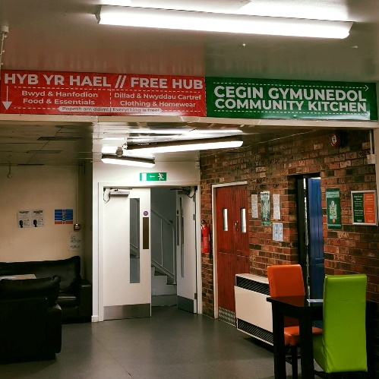
The union has been up to a lot this term with Aber Challenge, SHAG Week, Empower Aber, The Rep conference and Arts Fest – all being a great success. It was great to see the engagement and feedback we received from all the events.
Our Free Hub and Essentials Hub is now fully up and running with students now being able to access the room during SU opening hours and you can take free food, essential items such as shower wash and deodorant. You can also take or swap clothes in our free hub and pick up plates, jewellery, books and movies and so much more all for free.
We hope to continue this work and engagement throughout the rest of the year. I want to personally thank all the students who have engaged with us this year either online or in person and thank all the Students’ Union staff who make these events and activities possible.

Ash – President
This has been a fun and very busy term for me with getting the ball rolling with Green Impact and hosting SHAG Week (sexual health awareness and guidance).
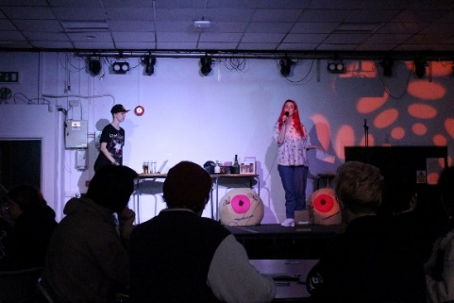
I was so happy with SHAG week and the engagement it received. We had over triple the numbers I was expecting, and the feedback was really great to make sure that if SHAG happens again, we reflect on any feedback and make it even better than this year. The Aerial Fitness event kicked off the week and had so many people attend to learn about body positivity and feeling comfortable in yourself. The cliterarty workshop taught students the anatomy of vulvas and vaginas and we had to get an extra table to accommodate everyone. On the Wednesday we had our kink workshop so that students knew about how to stay safe if they are going to participate in this type of sex and the importance of consent throughout. The whole picture house was full and had some great questions and feedback at the end. That evening we help a Netflix viewing where we showed ‘Sex Explained’ a documentary about what sex is. On the Friday we had our final event which was the Sexy Quiz. We had 69 people attend this event which is incredible. It was a fun night where students learnt some fun and engaging sexual health education based on genitals, safe sex, LGBTQIA+ and passion. I want to thank everyone who attended these events and I look forward to continuing this campaign with smaller activities throughout the year.
This term I have been working on a few other things as well. I have been planning a disability in higher education panel where we have ex-students, current students, student services and a member of Disability Wales on the panel. This is a chance to talk about students who have a disability in higher education and to answer any questions they may have.
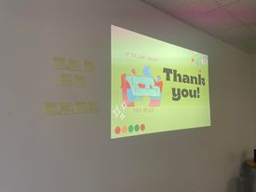
I also attended NUS Strategic Conversation with our CEO Trish at the end of November where we spoke about ways forward for Students’ Unions and how we can support students during the Cost-of-Living crisis. It was also a great opportunity to see what other Unions are doing and see if there is anything we can bring forward.
I also had the opportunity to speak at the Rep Conference put on by one of our student Ambassadors. I spoke about sustainability in higher education and how reps can interact with this and speak to students to receive feedback.
As well as this I have been working on ways to help students in the cost of living and the union has been working closely with the university to make some changes to benefit students during this hard time.

Dafi – UMCA President and Welsh Culture Officer
Dafi has been continuing his work with UMCA whilst also attempting to expand their relations elsewhere. UMCA events such as Sŵn have been successfully organised and many plans are being made ahead for a busy Christmas period. Y Ddawns Rhyng-gol was also successfully held ond the 19th of November, with Meinir Gwilym being a brilliant headline, on what was a great night with Welsh students from all over Wales.
A recent visit was made by Cardiff SU to Aber, welcomed by Dafi, to discuss their new full time sabbatical Welsh culture role which will be starting next year. It was a good chance for them to learn, but also to make connections and for us to hear their thoughts about the role and how we work.

Rachel – Student Opportunities
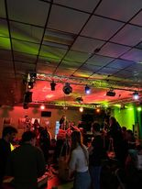
Since the last Senedd meeting, Rachel has settled into the first crux of Key Events and campaigns. Aber Challenge featured a fully recyclable Tower Construction, collaborations with ACOG, Beer Pong and Aber Pool for their events and the introduction of a (the first ever) mystery event which took the form of an old school sports day. Next, #EmpowerAber featured a variety of activities promoting female empowerment through taking part in extra-curricular activities.
In the recent Sports and Societies Zone, a priority was placed on discussing university facilities as Rachel was aware that this was a pressing issue which she wanted to tackle.
Coming up is Arts Festival, which Rachel has yet again collaborated with numerous clubs and societies to collate a variety of workshops and showcases. The week will end with a One World Night to celebrate culture alongside creativity.

Elizabeth – Academic Affairs
Elizabeth has been working on carrying over her priorities from last year. These include diversifying the curriculum, continuing to create a community for academic reps and to continue and solidify the postgraduate network she created last year, so that it can be carried on when her role is succeeded in July. In relation to decolonising the curriculum, Elizabeth is continuing to work with the university on their race access project and also delivered a diversifying the curriculum session at the rep conference on Saturday (26/11). Elizabeth held a rep conference for academic reps which included different talks from SU and uni staff. She also held a rep meet and greet after the Academic Zone for reps to meet each other and work in teams. This was important for creating a community amongst academic reps and has increased the engagement from reps in their role. Elizabeth is excited to carry on the postgraduate network, which already has 40 more members than last year, making the numbers 181. She is grateful for the help from the graduate school in creating this network and also from the SU comms team in getting more postgraduate students involved with the student’s union and setting up a webpage for the network. She will be hosting a postgraduate coffee morning next week for students in the network. Elizabeth also helped devise EmpowerAber, which has taken over from This Girl Can at AberUni SU. She had reps write articles about being a woman in their field and also organised a women’s meet & greet and women’s PG coffee morning.

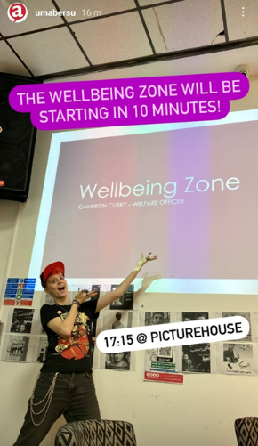
Cameron – Wellbeing Officer
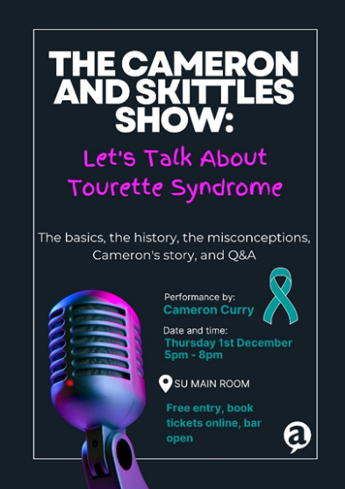
Since the last Senedd, Cameron has been involved largely with Disability History Month. He put together a talk and Q&A for staff and students about Tourette Syndrome, The Cameron and Skittles Show. It took place 1st December. In this presentation, he covered what Tourette’s is, the misconceptions around the condition, he shared his personal story and experiences, and took questions from the audience. Cameron was also part of the Disability Panel where he spoke about his experiences of being a disabled student. 9th November, Cameron held his first Wellbeing Zone where he discussed and took feedback for his priorities and other issues from students. He also wrote statements which went out to students on social media for awareness days we’ve had – Trans Day of Remembrance, White Ribbon Day, and Men’s Mental Health Awareness Month. Alongside all of this, Cameron has continued to work on his gender affirming products campaign, Beyond the Binary which will provide gender affirming products to students who cannot afford them.

