Officer’s Report
Sabina O’Donoghue

Senedd
01/11/2021

President’s Summary:
This year has started in the best way we can possibly imagine after the tough two years we’ve had. It has been so great to welcome students back on campus for in person events. We are extremely excited to jump right into to our roles and start working on our priorities.
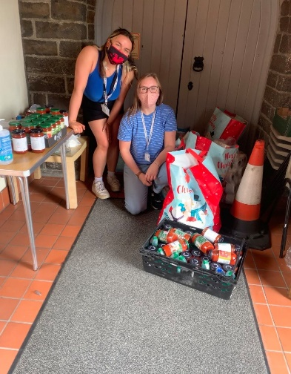
Our first month in the role was solely based around training us for our roles and responsibilities. We also did lots of team building and getting closer together as a team. This is shown by how well we’ve worked together over the past couple weeks in helping run freshers and working together on different campaigns and issues.
We sit on different committees and boards across the university such as Council, Senate and Academic Board to ensure your student voices are heard. It’s been super interesting to engage with these committees in person after meeting strictly online for the first couple of months.
In terms of little things we’ve been helping with, Mared and I donated a lot of our surplus non-perishables to a food bank. The many trips back and forth to the car and the sweat shed was super rewarding.
Helo Aber – Freshers Week
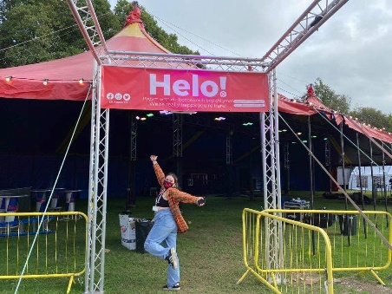
Freshers was a huge success for us. Getting events back up and running and in person was a tough task but to see students back and enjoying the Students Union again was a major reward! With that we’d like to say a big thank you to the Opps team for all the hard work they’ve put in over the week.
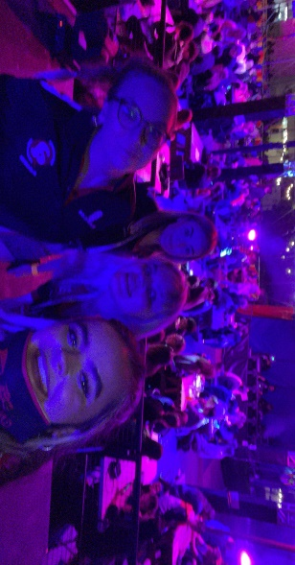
Our night-time events were a huge success. Our Officer quiz kicked off the Helo Aber events with a bang – to see ticket numbers jump from 101 to 423 within 24 hours and having to lead two simultaneous quizzes was daunting but we loved every second! We spent the rest of the week helping out with wristbanding and it was great to see our freshers and students who’ve missed out enjoy themselves.
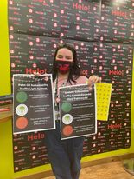
We also organised numerous meet and greets for students historically marginalised in higher education throughout the week including LGBTQ+, Women’s and Postgrad. We got to enjoy a wine and cheese night, we took part in poster making as well as some liberation centred quizzes. All of these meet and greets were a great success with a special thanks to Alice for organising everything and making sure it all ran smoothly.
Environment and Sustainability
I’ve been working mainly on two policies that were passed over the past couple years, but due to Covid were put on the backburner. I’ve been working closely with the SU shop in getting our Palm Oil Sustainability Traffic Light System set up. This means that any products containing palm oil or sustainable palm oil are labelled accordingly.
I’m currently working to see how we can go about NUS Student Switch Off, specifically around the comms that we can do to promote reduced energy usage in university halls.
We’ve got a group of student volunteers who are passionate about the environment. Through campaigns, education, events, collaboration and action, the Green Team will help to build awareness and create change concerning environmental issues across the University and/or local community. As a student-led project, students will be able to choose the type of environmental issues they’d like to focus on. But they will also work closely with the Environment and Sustainability Officer who will bring knowledge of current issues and the work being undertaken by the University or Students’ Union, which may influence the type of action they work towards. Email Amy (alg51) our SU volunteering coordinator to express you’re interested.
Student Safety at Night
Hannah and I are working closely to tackle the issues relating to student safety at night. We’re looking at getting funding from DARO’S wellbeing fund, HEFCW and the Home Office, in hopes of providing resources to our students such as drink cup covers and possibly drink testing kits. We want Aber to be as safe as possibly for our students so we’re also working with local venues and getting in contact with more venues with a possibility of starting a community wide pledge to keep our students safe.
New Staff
As well as saying a very sad goodbye to Martin, our Student Support and Representation manager, we’ve welcomed Chris onto our team as Welsh Community Coordinator and Felix as our new SU Translator. We’re super happy to welcome both to our team!!
Mared – UMCA President and Welsh Culture Officer
Over the past few weeks the UMCA Committee have been busy welcoming back students and helping them get settled in to Aber life. We had a very successful Freshers week with various events to suit everyone’s taste. We have also been joined by Chris Parry the new Welsh Community Coordinator who’s been working with UMCA on our priorities for the year and organizing upcoming events. The first main event will be Dawns Rhyngol and I already have the bands and sound systems booked, will need to sort accommodation for visiting Universities for the Friday night. On the Friday there’ll be a poetry ‘stomp’ competition down in The Llew Du pub then on the Saturday all Universities will be competing within different sports (Football, Rugby, Netball), followed by a gig up in the SU main Room on the Saturday.
Welsh lessons will be taking place for an hour a week to all those interested and I’m working with the Welsh 2nd language officers to organise various activities in order to advertise Welsh culture to the wider student population.
Aelwyd Pantycelyn will be restarting rehearsals gradually in Pantycelyn – we’re in the process of controlling capacity and considering options such as holding outside rehearsals in order for us to be able to sing. This will be another great way for students to interact and get to know each other a little better.
Rachel – Student Opportunities
Over these past few months, Rachel’s role has revolved heavily around Freshers and our Welcome Events. In addition to the Helo Aber events in the Big Top, the Main Room was offered out to clubs and societies to become part of our Welcome Week schedule, and this was an amazing way to introduce new and existing students back into what Tim Aber can be, after what has been a difficult couple years. Each of these events were advertised on the SU website on the main SU social media channels by Rachel and we’re happy to say that the clubs and societies that took these opportunities smashed it. Rachel was also approached at the start of my term about a student-led Ceilidh to happen just after Welcome Week and it was such a great success that there’s talk of a next one – Rachel’s overall aim as Opportunities Officer is to bring the fun and hype back to the SU and to put students at the forefront and with all of these events happening and being discussed, its great to see what students have achieved so early on in the year.
Other key moments included Rachel’s first Sports and Societies Zone, seeing the new season of BUCS starting back and getting to work on our upcoming key events like Give it A Go, Aber Challenge and Arts Festival. Also, with Rachel’s priority of developing inclusive clubs and societies, she will be working with Hannah to develop the No Excuses Training to deliver to committee members to highlight and promote that student safety is paramount. A big thank you to the opps team for welcoming Rachel with open arms!!
Elizabeth – Academic Affairs
As part of Elizabeth’s role, she has been working on her three priorities for the year. Firstly, she has started to create a new postgraduate network with the aim for postgrad students to meet other students on the same academic level as them. Through this network they can gain access to new opportunities in the shape of different talks, social and networking events. As well as making postgrad students more aware that the SU is a resource that is not only accessible to undergrads. The postgrad network started with a very successful meet & greet, which exceeded expectations. Elizabeth is currently organising a postgrad poster competition themed around COP26 and the uni’s COP26 Festival of Research.
Elizabeth’s second priority is decolonising the curriculum. She has created a form which will be used by students to feed-back on how diverse their lectures are and whether they feel represented by the curriculum. As part of this priority, she will also push the university on their race action plan.
Elizabeth’s third priority is to work with academic reps more closely and make sure they have a good working relationship with the academic affairs officer from this year onwards. This has been done, so far, by recruiting reps, talking to returning reps and organising the first rep meet & greet of the year. Elizabeth also attends several meetings in her role. One of which is a digital capability group, which looks to improve the digital capabilities of both students and lecturers. This is very relevant and important in this newly hybrid online/in-person teaching environment, to make sure everything runs smoothly.
Elizabeth also meets with the Associate Deans of Learning and Teaching, plus Registry staff to talk about matters such as special circumstances and registry issues. She meets monthly with IS & the library to feedback issues and hear any issues students have gone to them about, as well as discuss matters such as library opening hours and timetabling. She is also part of a student voice group where we have been shaping the MEQ questions and discussing the next National Student’s Survey. Elizabeth has also picked up policies, that were passed through Senedd last year, and has started to get in contact with the uni about them to make sure they can be completed.
Hannah – Wellbeing Officer
Hannah’s main priority is the safety and protection of women in Aberystwyth. In the past couple of months, she has been working alongside Harri Mason-Evans, the Serious Violence and Organised Crime Coordinator for INTACT at Dyfed-Powys Police to submit a bid for funding from the SWAN initiative. She has also been working alongside Harri to work on initiatives that can be put in place should this funding be unsuccessful. These initiatives include having safter routes home, safe spaces around town and an improved reporting system for incidents in and around town. Her other priorities include highlighting and acknowledging the importance of men’s mental health and promoting and supporting improved overall wellbeing on campus. These priorities include seeing the implementation of outdoor water fountains around campus and more motivational & diverse material throughout the gym and university. It also includes working with both external and internal organisations to put in place more male-focused mental health services and support groups.

