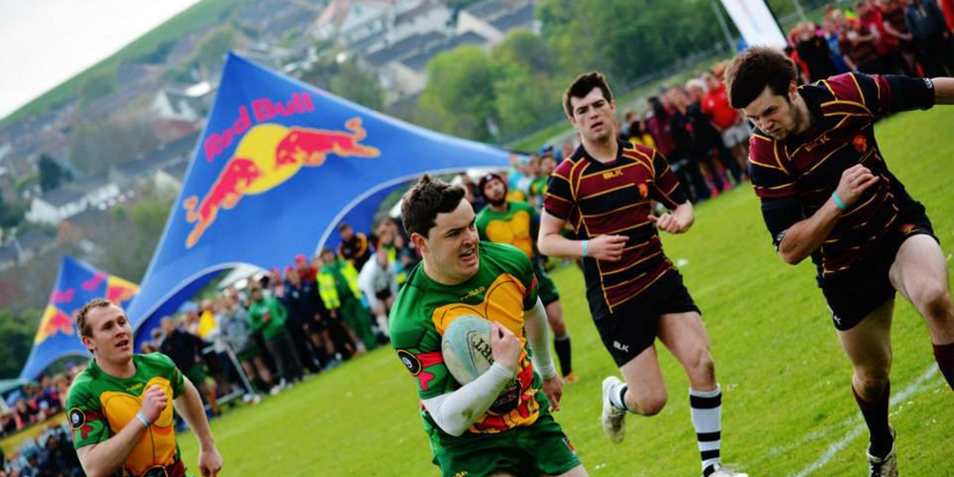

|  |  |
| --- | --- |
| **Aber7s** |  |

**Approximate engagement: 1,200 players and 500 spectators**

The annual Aber7s Festival attracts 1,200 rugby players & 500 spectators to one of the biggest rugby tournaments in Wales, bringing a small seaside town to life over the May Day weekend (2nd - 3rd May 2020).

This year’s Aber7s promises to be the biggest yet; with a total of 80 rugby teams and a social rugby competition. With your help, we will grow event for the benefit of the students, the town and the whole community. Please look at the sponsorship packages and get in touch.

|  |  |  |  |
| --- | --- | --- | --- |
|  | **Competition** | **League** | **Pitch** |
| **Banner** (200x80 cm) | ✓ | ✓ | ✓  (provided by sponsor) |
| **Announcements on the day** | ✓ | ✓ | ✓ |
| **Brand presence on Aber7s website** | ✓ | ✓ | ✓ |
| **Social Media Post** | ✓ | ✓ | ✓ |
| **Entry Passes to Aber7s** | ✓  (up to 5) | ✓  (up to 2) |  |
| **Present an award at the Ceremony** | ✓ |  |  |
| **Mentions throughout marketing activities as one of the five main sponsors** | ✓ |  |  |
| C:\Users\Olivia\Downloads\BJMoPetCIAA6LQ- (1).jpg | £300 +VAT | £150 +VAT | £100 +VAT |

**Key information**

* **Competitions**: Men’s Premier, Men’s Intermediate, Men’s Social, Women’s Premier, Mixed Tag Rugby
* **Date of the event**: 2 & 3 May
* **Deadline for booking**: 1 February
* **Deadline for artwork**: 7 February

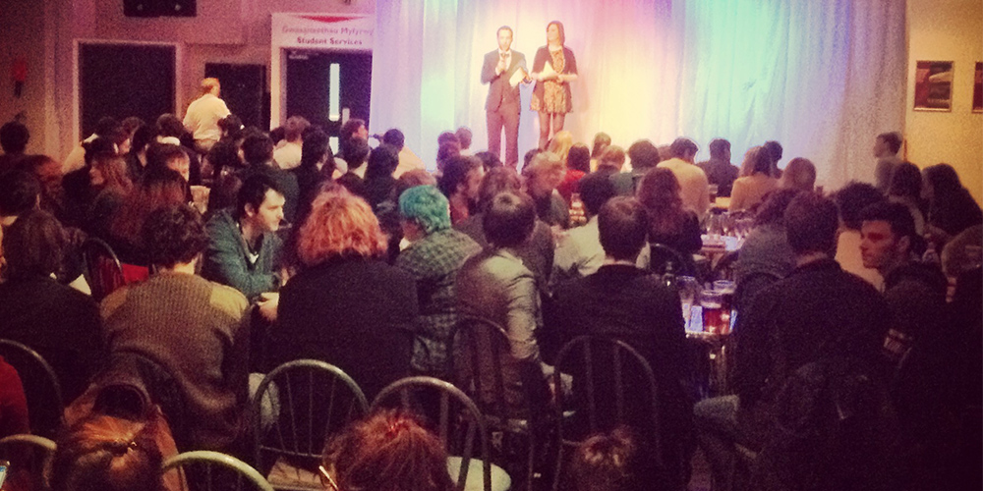

|  |  |
| --- | --- |
| **Leadership Elections** | **C:\Users\mul8\AppData\Local\Microsoft\Windows\INetCache\Content.Word\Stand @2x.png** |

**Approximate engagement: 3,000 students**

Students lead in all aspects of the Students’ Union. Leadership Elections is one of our most high-profile events. We use a democratic process to help students decide who should represent them on a range of issues for the following year.

During the last elections, our marketing efforts attracted **2,813 voters (37% of students)** which was a **record turnout for Aberystwyth Elections.** We intend to engage even more people this year.

|  |  |
| --- | --- |
| **Leadership Elections Sponsorship** | |
| * **Brand presence on AberSU Election marketing materials** * **Brand presence on all marketing materials**    + **3,000 flyers**   + **100 posters**   + **2 banners** * **Seat at the Results Night** * **3 Facebook and 3 Twitter posts** | £1,000  +VAT |

**Key information**

* **Date of the event**: 9th - 13th March 2020 (voting)
* **Deadline for booking**: 1 February
* **Deadline for artwork**:7 February



|  |  |
| --- | --- |
| **AberSU Celebrates** | C:\Users\Matt\AppData\Local\Microsoft\Windows\INetCache\Content.Word\celbr.jpg |

**Approximate engagement: over 1,000 students and university staff**

AberSU Celebrates (28th – 30th April) is our chance to honour and celebrate incredible impact that Sports Clubs, Societies, Staff and Students had over past year.

The week kicks off with Societies Awards on 28th April, followed by Sports Awards on 29th April and ending with the Staff and Students Awards on 30th April.

|  |  |  |  |
| --- | --- | --- | --- |
|  | **Main Sponsor** | **Event Sponsor** | **Individual Award** |
| **Present one award** | ✓ | ✓ | ✓ |
| **4 passes to the event** | ✓ | ✓ |  |
| **Promotional material on tables during the event** | ✓ | ✓ |  |
| **3 Facebook and 3 Twitter posts** | ✓ |  |  |
| **Brand presence on marketing materials (flyers, banners, posters, event program)** | ✓ |  |  |
| C:\Users\Olivia\Downloads\BJMoPetCIAA6LQ- (1).jpg | £1,000 +VAT | £300 +VAT | £50 +VAT |

**Key information**

* **Events:** Sports Awards, Societies Awards and Staff and Students Awards
* **Individual Award**: list will be available on www.abersu.co.uk
* **Deadline for booking:** 11 March (or December 2019 if possible)
* **Deadline for artwork:** 15 March (or December 2019 if possible)

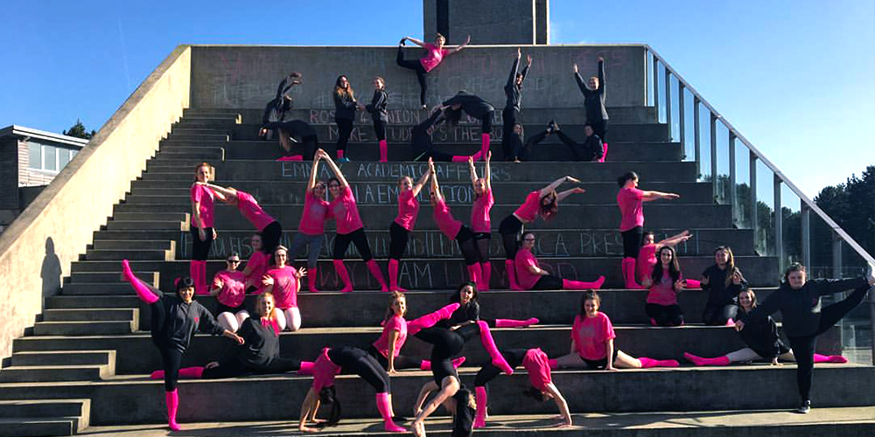

|  |  |
| --- | --- |
| **Varsity** | C:\Users\Matt\AppData\Local\Microsoft\Windows\INetCache\Content.Word\varsity.Facebook.180x180.jpg |

**Approximate engagement: 500 Aber students** (+500 Bangor students)

This year’s Varsity will take place in March at various venues across Bangor. The tournament sees hundreds of students from over 30 sports teams and societies compete for the Aber vs Bangor Varsity Trophy. Team Aber societies will be looking to retain the Societies Trophy after winning it comfortably last year, whereas our clubs will be looking to reclaim the Sports Trophy after 5 consecutive losses since 2015… No pressure!

|  |  |  |  |
| --- | --- | --- | --- |
|  | **Main** | **Sliver** | **Bronze** |
| **Brand presence on the AberSU varsity webpages** | ✓ | ✓ | ✓ |
| **2 Facebook and 2 Twitter posts** | ✓ | ✓ |  |
| **Brand presence in email signature of all Union staff** | ✓ |  |  |
| **Brand presence on all printed communications (flyers, posters, banners)** | ✓ |  |  |
| **Addition to Varsity Pack (500 pieces)** | ✓ |  |  |
| C:\Users\Olivia\Downloads\BJMoPetCIAA6LQ- (1).jpg | £700 +VAT | £100 +VAT | £50 +VAT |

**Key information**

* **Date of the event**: 21 March 2020
* **Deadline for booking**: 2 March
* **Deadline for artwork**:9 March

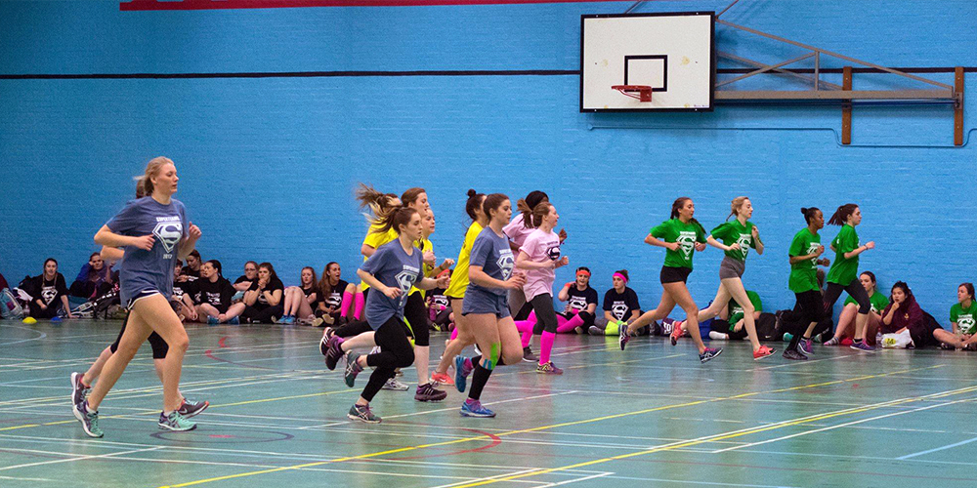

|  |  |
| --- | --- |
| **Superteams** | C:\Users\Matt\AppData\Local\Microsoft\Windows\INetCache\Content.Word\Superteams-logo.jpg |

**Approximate engagement: 700 students (560 participants + spectators)**

Superteams is THE must attend event of the year for Aberystwyth students. Students organise themselves into teams of 10 and compete in a huge variety of activities and sports across the weekend. Prepare yourselves for banter, sweat and a lot of mud! With events ranging from basketball to bleep test, football to obstacle courses, this weekend is most certainly not for the faint hearted. Last year event sold out in 5 minutes.

|  |  |  |  |
| --- | --- | --- | --- |
|  | **Main Sponsor** | **Event Sponsor** | **Individual Award** |
| **Brand presence on website** | ✓ | ✓ | ✓ |
| **2 Facebook and 2 Twitter posts** | ✓ | ✓ |  |
| **Present awards** | ✓ |  |  |
| **Brand presence in all promotional materials (flyers, posters, banners)** | ✓ |  |  |
| **Addition to Superteams merchandise pack** | ✓ |  |  |
| C:\Users\Olivia\Downloads\BJMoPetCIAA6LQ- (1).jpg | £600 +VAT | £200 +VAT | £50 +VAT |

**Key information:**

* **Weekend Sponsor:**
  + Women’s: 14- 16 February
  + Men's: 21- 23 February
* **Deadline for booking**: 31 January
* **Deadline for artwork**:7 February

**Booking Form**

By booking you agree to T&Cs in the AberSU Media Pack 2019 (available at abersu.co.uk/advertising)

|  |  |
| --- | --- |
| **To book please fill in the details below.** | |
| **Event** |  |
| **Package Chosen** |  |
| **Organisation** |  |
| **Contact Name** |  |
| **Address & Post Code** |  |
| **Contact Number** |  |
| **Email** |  |
| **Date** |  |
|  | **I would like to receive information about upcoming marketing opportunities provided by the Students’ Union and collecting feedback.** Your data will be used in accordance with GDPR and stored for a period of 3 years. We will not share your data with 3rd parties. You can have your details amended at any time by contacting us. |

|  |  |
| --- | --- |
| **To honour the terms of the sponsorship we will need payment before the event. Payment options:** | |
|  | cheque - payable to “Aberystwyth University Students’ Union” |
|  | BACS after receiving an invoice. Purchase Order: _________________ |
|  | card over the phone: 01970 62 17 04 |
|  | cash (date) _________________ |

|  |  |
| --- | --- |
| **Return to** | |
| **Matt Lukasiak**  **01970 62 1704** | [mul8@aber.ac.uk](mailto:mul8@aber.ac.uk)  Students’ Union, Penglais, Aberystwyth, SY23 3DX |

**Data Protection Declaration**

In providing my information I understand that I am required to provide my details, as outlined below, to Aberystwyth University Students’ Union, and that they will be held in compliance with the Data Protection Act (DPA) 2018 and with the General Data Protection Regulation (GDPR), along with the University and AberSU data protection policies.  They will be retained on the basis that AberSU has a legitimate interest in processing them and that it is also necessary for the performance of a contract.

Details will be kept for up to four years as a record of involvement, invoicing and for statistical purposes. I understand that I can object to certain aspects of processing by emailing [union@aber.ac.uk](mailto:union@aber.ac.uk). The Union’s Data Protection Statement and Policy is reviewed annually to ensure compliance and is available on request or by visiting: [www.abersu.co.uk/aboutaber/dataprotection](http://www.abersu.co.uk/aboutaber/dataprotection)

Your personal data will not be shared outside of the Students’ Union without your explicit permission.

**What details do we need you to share?**

* Name of organisation
* Name of person booking the service
* Address and Post Code
* Contact number
* Email

|  |  |
| --- | --- |
| **Organisation** |  |
| **Signature** |  |
| **Date** |  |