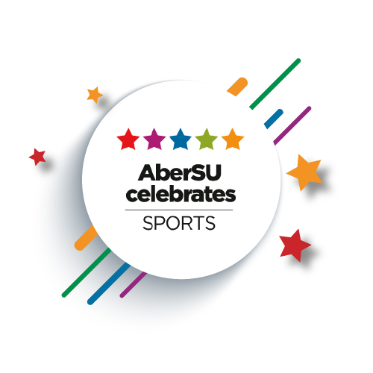

Awards Criteria:
Award | Criteria
Sports Person of The Year | This is awarded to the individual who has excelled in their chosen field of sport and has enhanced the reputation of sport in Aberystwyth. They have represented on a regional / national level or have excelled within the university sports structure.
Sports Personality of The Year | Awarded to an individual who shows a good sense of sportsmanship, commitment, humour and enthusiasm in all aspects of their sport and the outward Team Aber community.
Gwyn Evans Trophy | Awarded in memory of a former PE lecturer and club coach, the award recognises personal dedication, commitment and a commendable sporting attitude towards achievement in sport. This is someone that takes on every role within the club, coach, player, supporter: he/she is the individual that everyone turns to in times of need.
Mary Anne Trophy | Awarded to someone who has been dedicated towards the running and administration of a particular club. He or she is the unsung hero who sits at the desk inputting emails or collecting money.
Club of The Year | The Club of the Year is the most coveted and sought-after award within Team Aber. This is awarded to the most successful, committed and active club of the academic year.
Biggest Contribution RAG | This is awarded to a club whose members have freely given a significant amount of their time to a good cause throughout the year, or a club that has significantly contributed towards RAG throughout the year.
Welsh Language Award | The club has exceeded the boundaries of the Bilingualism Policy and has included bilingualism print on official club clothing. In addition, all of their correspondence has been in bilingual, and the club committee also includes a Welsh Language Officer/ Translation Officer, and the club upholds the bilingual policy at their events.
BUCS Team of The Year | Awarded to the team that has competed exceptionally in their BUCS competition. This team has represented the university well at national level furthering the reputation of Aberystwyth University..
Non - BUCS Team of The Year | Awarded to the team that has competed exceptionally in their competition. This team has represented the university well and furthered the reputation of Aberystwyth University.
Most Improved Club of The Year | The criteria for this award are improved success, spirit and organisation of a club. They should also demonstrate a dedication to carrying on this progression for future years.
Committee Excellence Award | For this award we are looking for a committee who have gone above and beyond to work together and provide a range of events/activities for their members. They will have worked effectively as a team, had good communication between themselves and members, and put inclusivity at the forefront. They will have actively engaged with SU events and activities; alongside building good working relationships with key areas of the SU, namely with members of the Opps Team, Finance staff, and other internal or external organisations.
University Colours: Sports (25) | Awarded to individual students who have shown continued outstanding dedication or made an exceptional contribution to their club, whilst also demonstrating commitment to the students' union and/or student sport. In exceptional circumstances, students may also be awarded full colours for excelling at their chosen sport to a high level, including winning an international/national or BUCS Competition or representing their sport at a national/international level.

