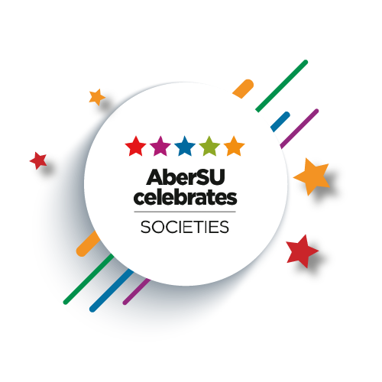

Awards Criteria:
Award | Criteria
Society Person of the Year | This is awarded to the individual who has excelled in their chosen field/interest and has enhanced the reputation of Aberystwyth. They may have represented their society on a regional/national level and/or have excelled within the university/union structure.
Societies Personality of the Year | Awarded to an individual who is highly valued within their society, but also shows a good sense of personal flair, humour and enthusiasm in all aspects of their society and the outward Team Aber community.
Administrative Excellence Award | Awarded to someone who has been dedicated towards the running and administration of a particular society. They are the unsung hero who sits behind the scenes; they play a critical role in the society reaching their achievements.
Society of the Year | The Society of the Year is the most coveted and sought-after award within Team Aber. This is awarded to the most successful, committed and active society of the academic year.
Welsh Culture Award | The society has integrated bilingualism into their activities and promotional material, alongside conserving Welsh culture/heritage and actively encouraged the involvement of Welsh speakers.
Biggest Contribution Award | This is awarded to a society whose members have freely given their time to a good cause throughout the year, has spent time helping the student/local community, or have fundraised for a good cause.
Academic/Course based Society of the Year | Awarded to an Academic Society who has made an outstanding contribution to their department, as well as to the Union, University and Wider Community.
Sustainability (Cultural/Social, Environmental and Economic) | This society has actively promoted sustainability within a wide range of their activities. This includes cultural/social sustainability, environmental sustainability and/or economic sustainability.
Committee Excellence Award | For this award we are looking for a committee who have gone above and beyond to work together and provide a range of events/activities for their members. They will have worked effectively as a team, had good communication between themselves and members, and put inclusivity at the forefront. They will have actively engaged with SU events and activities; alongside building good working relationships with key areas of the SU, namely with members of the Opps Team, Finance staff, and other internal or external organisations.
Most Improved Society of the Year | This is awarded to a society who has significantly increased the engagement and quality of its members and society in comparison to the previous year. This can be through, but not limited to, increased range of activities provided, improved communications, collaboration, etc.
Best New Society | Awarded to a society that has started, or has been restarted, in the last academic year. They have worked hard to establish themselves in the TîmAber community, alongside having a positive impact on the student community.
University Colours: Societies (25) | Awarded to individual students who have shown continued outstanding dedication or made an exceptional contribution to their society.

