Fire Risk Assessment
Students Union
Penglais
Aberystwyth
SY23 3DX

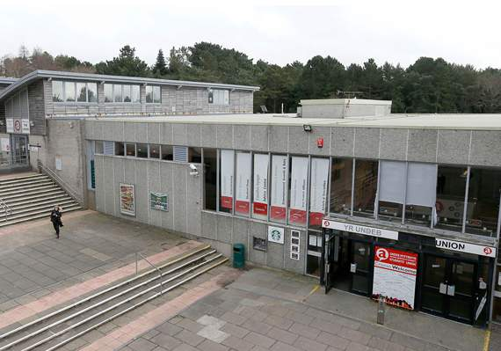

Assessment Undertaken by: Andy Wainwright BEng (Hons) Fire Engineering, EngTech, TIFireE
This report consists of two sections; Section A is an assessment of the risk to life from fire in the premises, Section B is an assessment of the risk to the building from fire.

PAS 79:2012 (Fire Risk Assessment. Guidance and a recommended methodology) has been used for evaluating the Risk to Life within the building.
Approved Document B: Fire Safety (Volume 2 Buildings other than dwellinghouses) Incorporating Insures’ Requirements for property protection has been used as the benchmark for evaluating the potential for property damage.

Contents

Regulatory Reform (Fire Safety) Order 2005 5
Fire Risk Assessment 5
Section A 7
General Information 7
1. The Premises 7
2. The Occupants 10
3. Occupants Especially at Risk from Fire 10
4. Previous Fires 11
5. Additional Matters Taken into Consideration 11
6. Relevant Legislation 11
7. Electrical Sources of Ignition 11
8. Smoking 12
9 Portable Heaters and Heating Installations 14
10 Cooking 14
11 Lightning 15
12. Housekeeping 15
13. Hazards caused by building works and outside contractors 16
14. Dangerous Substances 17
15. Process or other fire hazards which have an impact on the general fire safety arrangements. 17
Fire Protection Measures 17
16. Means of Escape from Fire 17
17. Fire Spread and Development 20
18. Emergency Escape Lighting 21
19. Fire Safety Signs and Notices 22
20. Means of Giving Warning in case of Fire 22
21 Manual Fire Extinguishing Appliances. 23
22 Automatic fire suppression system 23
23 Other relevant fixed systems and equipment 23
Management of health and safety 24
24. Procedures and arrangements 24
25. Training and Drills 27
26. Testing and Maintenance 30
27 Records 33
Fire Risk Assessment 34
Action Plan 37
Significant Findings 38
Conclusions 38
Section B 39

Appendix A 40
Figure 1 - Location 5
Figure 2 – Floor Plan 9
Figure 3 - Chiller obscuring fire exit 40
Figure 4 – Rear exit from lower ground floor due to leaves moss and other organic matter 40
Figure 5 – Excessive gap between door leaves 41

Regulatory Reform (Fire Safety) Order 2005

Fire Risk Assessment
Responsible Person (e.g. employer) or person having control of the premises:
Professor Elizabeth Treasure - Vice-Chancellor of Aberystwyth University

Address of Premises
Students Union
Penglais
Aberystwyth
SY23 3DX

Site Map
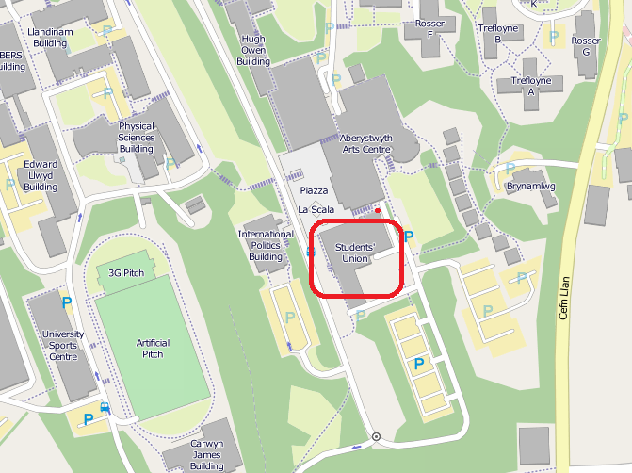
Figure 1 - Location

Date of Fire Risk assessment
17/1/19

Date of Previous Fire Risk Assessment
7th July 2016

Date for Review
17/1/20

Section A

General Information

1. The Premises
1.1 Number of Floors
3

1.2 Approximate floor area
First Floor – 450m²
Ground Floor - 1450 m²
Lower Ground Floor – 1050m²

2950m² gross

1.3 Description of premises
Constructed in the 1960s, Aberystwyth University Students Union building is a purpose built Assembly and Recreation building comprising of Bars, Shops, Meeting rooms and Office accomodation.
The construction method of the original building, consists of a concrete frame of columns and connecting beams, forming the load-bearing elements of the building.
Concrete and glass curtain walling forms the weather protection to the building.

The building is located on a relatively steep site. Access to the building is available on three distinct levels; the ground, lower ground and first floors.
The building was extending in the 1990s to include a shop and office space. The extension is comprised of a steel frame with concrete block infill and decorative cedar cladding to the exterior façade.
The main entrance from the Piazza, forms the principle entrance to the building. This opens into the reception area located on a half landing. Stairs lead down to the lower ground floor and up to the ground floor. A lift is provided for disabled patrons to access the lower ground and ground floor.
In addition to the main entrance, level means of escape are available from the lower ground, ground and first floors.
A kitchen is located on the lower ground floor providing fast food for the sales outlet located within in the main bar.

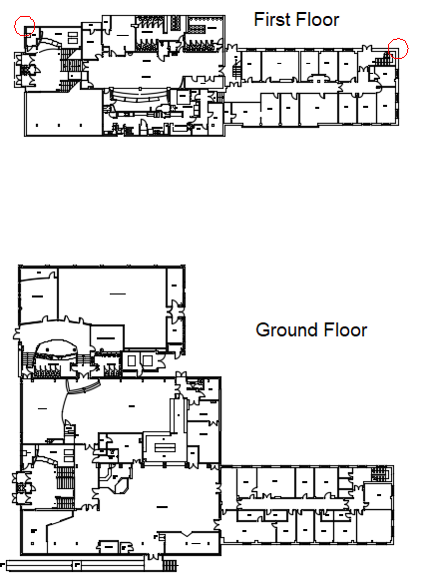
Figure 2 – Floor Plan

1.4 Use of Premises
Assembly and Recreation – Approved Document B – Volume 2

2. The Occupants
2.1 Maximum number of occupants
Function room 550 persons
Bar 500 persons
The Street 50 persons

2.2 Maximum number of employees at any one time
30 persons

2.3 Maximum number of members of the public or students at any one time
< 1100 persons.

2.4 Approximate times of occupation
Varies – depending upon events and activities.

3. Occupants Especially at Risk from Fire
3.1 Sleeping
None

3.2 Disabled
Wheel chair access is available via the First, Ground and Lower-ground floors. Wheel-chair egress is available from all floors.

3.3 Lone Workers
Small number < 10 persons, may consist of University Staff or External Contractors.

3.4 Young Persons.
None.

3.5 Others.
< 50 persons consisting of Students, Staff and Visitors.

4. Previous Fires
None

5. Additional Matters Taken into Consideration
In the event of larger scale events SIA (security industry association) licensed door supervisors are contracted in.

6. Relevant Legislation
6.1 Applicable Fire Safety Legislation
The Regulatory Reform (Fire Safety) Order 2005

6.2 Enforced by
Mid and West Wales Fire and Rescue Service

7. Electrical Sources of Ignition
7.1 Are reasonable measures taken to prevent fire of an electrical origin?
Yes | No

7.2 Has the fixed electrical installation been inspected and tested?
Yes | No

7.3 Have the portable appliances been tested?
Yes | No

7.4 Are electrical extension leads being used in accordance the manufacturer’s instructions?
Yes | No

7.5 Comments and Hazards Observed
All portable electrical equipment owned by the Aberystwyth University is tested for electrical safety on an annual basis.
An external contractor visits at the start of every academic year to test any electrical equipment brought on to the premises by students.
Periodic testing of the fixed installation wiring is undertaken at a maximum of five yearly intervals.
The electrical installation was deemed compliant when tested on the 19/4/18.

8. Smoking
8.1 Are reasonable measures taken to prevent fire being caused by smoking?
8.2 More specifically
Is smoking prohibited on the premises?
Yes | No

8.3 Is smoking prohibited in appropriate areas?
Yes | No

8.4 Are designated smoking areas provided?
Yes | No

8.5 Is the policy being adhered to?
Yes | No

8.6 Comments and hazards observed
Aberystwyth University smoking policy: https://www.aber.ac.uk/en/media/departmental/healthsafetyenvironment/documentmanagementsystem/policiesandprocedures/P008-Smoking-Policy.pdf

8.7 Has reasonable provision been made to prevent arson by persons not connected to the University?
Yes | No

8.8 Are waste bins and other combustible materials stored in a separate compound away from the building?
Yes | No

8.9 Is the outside of the building secure?
Yes | No

8.10 Is sufficient lighting and CCTV provided to monitor the exterior of the building?
Yes | No

8.11 Comments and Hazards Observed
External lighting and CCTV coverage is considered to be satisfactory.
Door security staff are utilised for events.

9 Portable Heaters and Heating Installations
9.1 Is the use of portable heaters avoided as far as is reasonably practicable?
Yes | No

9.2 Where portable heaters are used:
Is the use of the more hazardous type (e.g. radiant bar fires or LPG appliances) avoided?
N/A | Yes | No

9.3 Are fixed heating installations maintained?
N/A | Yes | No

9.4 Comments and Hazards Observed
The use of portable heaters is discouraged. The premises benefits from a conventional wet type central heating system with radiators to transfer the heat from the system to the rooms.

10 Cooking
10.1 Have reasonable measures been taken to prevent a fire occurring in a cooking area?
Yes | No

10.2 Are any grease filters and associated ductwork subject to suitable maintenance regime?
Yes | No

10.3 Comments and Hazards Observed
Cleaning of the ductwork and grease filters form part of the Planned Preventive maintenance routine. A deep clean of the filters and ductwork was completed in December 2018

11 Lightning
11.1 Does the building have lightning protection?
Yes | No

11.2 Comments and Hazards Observed
Not Applicable

12. Housekeeping
12.1 Are combustible materials separated from ignition sources where it is reasonably practicable to do so?
Yes | No

12.2 Are Suitable measures in place to avoid the accumulation of combustible materials and waste?
Yes | No

12.3 Are hazardous materials appropriately stored?
Yes | No

12.4 Are combustible materials stored in such a way not to pose a hazard?
Yes | No

12.5 Comments and Hazards Observed.
Storerooms should be kept locked shut when not in use.

13. Hazards caused by building works and outside contractors
13.1 Are fire safety conditions placed on contractors?
Yes | No

13.2 Is a suitable system in place to maintain control over outside contractors (e.g. permit to work, hot work permit)?
Yes | No

13.3 Is a suitable system in place to maintain control over in house staff (e.g. permit to work, hot work permit)?
Yes | No

13.4 Comments and Observations
All contractors receive a Health and Safety induction prior to commencing work on any of Aberystwyth University’s premises. In the event contractors are working on AU premises, they are required to sign in and out at the security lodge on Penglais campus. Permit to work system and hot work permit required where necessary.

14. Dangerous Substances
14.1 Are the hazards associated with dangerous substances adequately controlled by the general fire precautions?
N/A | Yes | No

14.2 If the answer to 14.1 is no; has a specific Fire Risk Assessment been completed as required by the Dangerous Substances and Explosive Atmospheres Regulations 2002 (DSEAR)?
N/A | Yes | No

15. Process or other fire hazards which have an impact on the general fire safety arrangements.
15.1 Hazards
None

15.2 Comments and Deficiencies observed
None

Fire Protection Measures

16. Means of Escape from Fire
16.1 Are the means of escape suitable to evacuate the premises in the event of fire?
Yes | No

16.2 Is the layout of the escape routes suitable?
Yes | No

16.3 Are sufficient exits provided for the type of premises and the number of people who may use them?
Yes | No

16.4 Do exits open in the direction of travel where necessary?
Yes | No

16.5 Are sliding or revolving doors used on exit routes or as final exit doors?
Yes | No

16.6 Are suitable fastenings fitted to doors on exit routes and final exit doors?
Yes | No

16.7 Are the travel distances within the limits specified in HM Guide to Sleeping accommodation?
Where more than one route is available?
N/A | Yes | No

Where only a single escape route is provided?
N/A | Yes | No

16.8 Are escape routes suitably protected from the effects of fire for a period of time sufficient for the occupants to evacuate?
Yes | No

16.9 Are the occupants of inner rooms provided with adequate warning of a fire in the access room?
N/A | Yes | No

16.10 Are the escape routes kept clear of obstructions and combustibles materials?
Yes | No See16.12

16.11 Area the premises provided with reasonable arrangements for the means of escape for persons with disabilities?
Yes | No

16.12 Comments and Deficiencies observed
Occupancy Rationale
The worst case scenario, with the building operating at maximum capacity, would be a fire incident located at the furthest part of the function room away from the entrance door. This would result in 550 persons having to exit via the remaining 2 doors each being 1520mm in width. Simultaneously you would have 500 persons from Starbucks exiting via the three available exits. Assuming they will divide equally between the available exits results in each exit being used by 166 persons. Therefore, the number of people using the stair will be 275 from the function room and 166 from Starbucks giving 442 persons.
The remaining stair-width (with the lift installed) is 1539mm. Typically the two guidance documents used for calculating the exit capacity, BS 9999 states; allow 4mm per person for two storey buildings, this gives a maximum capacity of 384 persons, Equation 4.25 in Approved Document B (ADB) gives the maximum capacity of the stairs to be 369 persons.
This indicates the remaining stair is not of sufficient width to operate the building at maximum capacity.
Starbucks however in this scenario would have its two exits available (past the shop and adjacent to the bar) which have a total maximum capacity of 741 persons. It is therefore reasonable to assume should there be a bottleneck at the head of the stair; persons who were in Starbucks would exit via one of these two routes.
Therefore it is unlikely 166 people from Starbucks will use the stair, but the majority will leave via the exit past the student union shop or the exit adjacent to the bar. If half of the people from Starbucks leave by one of these two exits, 86 people would use the stair along with the 275 from the function room. This results in 358 persons needing to use the remaining stair which has a maximum capacity of 369 (ADB).

Therefore, the remaining stair should have sufficient capacity to allow for the full and simultaneous evacuation of the building operating at its maximum capacity.

An Annual Inspection of fire doors undertaken by Aberystwyth University’s Estates, Facilities and Residencies Department.

The chiller (Figure 3, appendix A), placed in front of the fire exit doors located at the rear of the bar area is to be removed or re-located, so as not to cause an obstruction

17. Fire Spread and Development
17.1 Is the compartmentation sufficient to limit fire spread?
Yes | No

17.2 Are the surface linings of a type which will inhibit the spread of fire within the building?
Yes | No

17.3 As far as can be reasonably ascertained are fire dampers present to protect means of escape from the effects of fire in its early stages?
N/A | Yes | No

17.4 Comments and Deficiencies Observed
The spread of fire and associated products of combustion may be restricted by sub-dividing buildings into a number of discrete compartments. These compartments are designed to contain the fire, providing sufficient time for the occupants to evacuate and restrict the extent of the damage to the building. The compartments are separated by fire rated construction consisting of compartment walls and floors.
The boiler room located beneath the building is fire separated from the upper floors by a concrete compartment floor affording 1 hour’s fire separation.
The licensed areas located on the upper floors are separated into four main compartments, each being separated by construction affording 30 minutes fire-resisting construction designed to inhibit the spread of smoke, fire and other products of combustion through the building.
The four compartments consist of:
- The lower ground floor (including kitchen)
- The main Function Room
- The bar (Starbucks)
- Shop and Careers office.

The fire doors (Figure 5. Appendix A) separating the lower ground floor from the reception area have an excessive gap between the door leaves. The purpose of this set of doors is to resist the passage of fire and hot gases including hot smoke and resist the passage of cold smoke. The door gap should be reduced to be 3 mm +/- 1 mm

18. Emergency Escape Lighting
18.1 Is a reasonable standard of escape lighting provided?
Yes | No

18.2 Comments and Deficiencies Observed.
BS 5226:1991 system provided within the building. Emergency lighting to illuminate the external pathway from the lower ground floor offices required.

19 . Fire Safety Signs and Notices
19.1 Reasonable standard of fire safety signs and notices?
Yes | No

19.2 Comments and Deficiencies observed.
None

20. Means of Giving Warning in case of Fire
20.1 Is an appropriate manually operated electrical fire alarm system provided?
Yes | No

20.2 Is Automatic Fire Detection provided?
Yes | No

20.3 If provided is the automatic detection system appropriate for the risk?
N/A | Yes | No

20.4 Is the fire alarm system connected to a receiving centre or other external party?
N/A | Yes | No

20.5 Comments and Deficiencies observed
Tested 26/6/18 - system functions satisfactorily

21 Manual Fire Extinguishing Appliances.
21.1 Are appropriate portable Firefighting Appliances provided?
Yes | No

21.2 Are the portable firefighting appliances suitable sited?
Yes | No

21.3 Comments and deficiencies observed.
Provided In accordance with BS 5306:3 2009

22 Automatic fire suppression system
N/A | Yes | No

22.1 Type of system
N/A | Yes | No

22.2 Comments and deficiencies.
N/A

23 Other relevant fixed systems and equipment
23.1 Type of system
N/A

23.2 Comments
N/A

23.3 Provision of firefighters switches
N/A | Yes | No

23.4 Comments
N/A

Management of health and safety

24. Procedures and arrangements
24.1 Fire safety is managed by:
AU Fire Safety Advisor and Aberystwyth University Compliance Manager

24.2 Are competent person/s appointed to assist in undertaking the preventative and protective measures?
Yes | No

Comments
None

24.3 Is there a suitable record of the fire safety arrangements?
N/A | Yes | No

24.4 Specifically - Appropriate procedures in place
Yes | No

24.5 Are procedures in the event of fire appropriate and properly documented?
N/A | Yes | No

24.6 Are there suitable arrangements for summoning the fire and rescue service?
Yes | No

24.7 Are there suitable arrangements to meet the fire and rescue service on arrival and provide relevant information, including that relating to hazards to fire-fighters?
N/A | Yes | No

24.8 Are there suitable arrangements for ensuring the premises have been evacuated?
Yes | No

24.9 Are there suitable fire evacuation muster points?
N/A | Yes | No

24.10 Are there adequate procedures for evacuation of any disabled people who may be present?
N/A | Yes | No

24.11 Comments
In the event of fire or a fire alarm warning, simultaneous evacuation commences. The fire alarm signal is relayed to the porters lodge. On receipt of the signal portering staff and/or security staff are mobilised via handheld radio to attend and investigate the cause of the alarm activation.
In the event of a confirmed fire, mobilisation of Fire Service is via 999 backed up with a call from the Alarm Receiving Centre.

24.12 Are persons nominated and trained to use portable fire-fighting appliances?
Yes | No

24.13 Comments:
Fire Safety Training includes Fire Extinguisher familiarisation.

24.14 Are sufficient persons nominated and trained to assist with evacuation for disabled persons?
N/A | Yes | No

24.15 Have the local authority fire and rescue service been informed of any risks as appropriate?
Yes | No

24.16 Comments
All occupants are able to self-evacuate (not requiring assistance) in the event of the fire alarm sounding.
In the event of the fire alarm sounding staff are instructed to evacuate the building and not fight the fire. Tackling a fire with First Aid Firefighting Equipment (fire extinguishers is discretionary).

24.17 Are suitable and sufficient measures in place to maintain the existing fire precautions?
Yes | No

24.18 Comments
Staff are instructed and encouraged to report any building defects either directly to the Estates Facilities and Residencies Helpdesk or via their line manager.
Fire safety measures are provided, tested and maintained in accordance with the relevant codes of practice.

25. Training and Drills
25.1 Are staff given adequate fire safety instruction and training on induction?
Yes | No

25.2 Comments
Staffs receive basic fire safety training on induction and are required to complete an online Health and Safety Module “Meeting the threat from Fire” within two weeks of starting their employment with Aberystwyth University.

Fire drill undertaken satisfactorily on the 14/10/18

25.3 Are staff given adequate periodic refresher training at suitable intervals?
Yes | No

25.4 Comments
Refresher training is provided to staff during fire drills, toolbox talks. Staff complete an online electronic training package “meeting the threat from fire” Annually.

25.5 Does all staff training provide information, instruction or training on the following?
25.6 Fire risks in the premises?
N/A | Yes | No

25.7 The fire safety measures on the premises?
N/A | Yes | No

25.8 Action in the event of fire?
N/A | Yes | No

25.9 Action on hearing the fire alarm signal?
N/A | Yes | No

25.10 Method of operation of manual call points?
N/A | Yes | No

25.11 Location and use of fire extinguishers?
N/A | Yes | No

25.12 Means for summoning the fire and rescue service?
N/A | Yes | No

25.13 Identity of persons nominated to assist with evacuation?
N/A | Yes | No

25.14 Identity of persons nominated to use fire extinguishing appliances?
N/A | Yes | No

25.15 Comments
In the event of a fire alarm activation staff instructed to evacuate the building and report to the assembly point.
Campus services staff (porters and security) will investigate the cause of a fire alarm activation.
If confirmed to be an actual fire the security team will call 999 to mobilise the emergency services.
The 999 call is backed up with an alarm receiving centre.

25.16 Are staff with special responsibilities (e.g. fire wardens) given additional training?
N/A | Yes | No

25.17 Comments
None

25.18 Are fire drills undertaken at appropriate intervals?
Yes | No

25.19 When the employees of another employer work in the premises:
Is there employer given appropriate information (e.g. on fire risks and general fire precautions)?
N/A | Yes | No

25.20 Is it ensured that the employees are provided with adequate instructions and information?
N/A | Yes | No

25.21 Comments
Risk Assessment and Method statements (RAMS) are required for all out-sourced works;
A risk assessment involves identifying hazards associated with the task. The hazard should be identified to determine if they present a risk that could harm someone. If there is a risk, control measures are required to eliminate or mitigate the risk.
RAMS are documents companies create after they conduct risk assessments. RAMS documents contain details of the hazard as well as a step-by-step safe working guide that employees, contractors, and others can follow.
The method statement must also detail which control measures have been introduced to ensure the safety of anyone who is affected by the task or process.
Hot Work Permits are needed for all cutting, welding, soldering and brazing activities, in occupied buildings, that are conducted with portable gas or arc equipment.

26. Testing and Maintenance
26.1 Adequate maintenance of premises?
Yes | No

26.2 Comments and deficiencies observed:
None

26.3 Weekly testing and periodic servicing of fire detection and alarm system?
N/A | Yes | No

26.4 Comments and deficiencies observed:
Weekly tests undertaken by Aberystwyth University security personnel.

26.5 Monthly and annual testing routines for emergency escape lighting?
N/A | Yes | No

26.6 Comments and deficiencies observed:
Monthly Testing Undertaken by Padarn Alarms

26.7 Annual maintenance of portable firefighting equipment?
N/A | Yes | No

26.8 Comments and deficiencies
None

26.9 Period inspection of external escape staircases and gangways?
N/A | Yes | No

26.10 Comments and deficiencies observed:
None

26.11 Six monthly and annual testing of rising mains?
N/A | Yes | No

26.12 Comments and deficiencies observed:
None

26.13 Weekly and monthly testing, six monthly inspection and annual testing of firefighting lifts?
N/A | Yes | No

26.14 Comments
None provided

26.15 Weekly testing and periodic inspection of sprinkler installations?
N/A | Yes | No

26.16 Comments
N/A

26.17 Routine checks of final exit doors and/or security fastenings?
N/A | Yes | No

26.18 Annual inspection and test of lightening protection system?
N/A | Yes | No

26.19 Are suitable systems in place for reporting and have subsequent restoration of safety measures that have fallen below standard?
Yes | No

26.20 Other relevant inspections or tests:
Annual gas safe inspections completed.

26.21 Comments
All fire doors are subject to an annual inspection by the Estates Fire Technician. Inspection of the external escape routes forms part of the annual Fire Risk Assessment Review.
Staff are instructed to report any matters relating to building defects reported to the Estates helpdesk 2999 internal.
The external escape route serving the lower ground floor office space is slippery underfoot due to an accumulation of leaves, moss and other organic matter.

27 Records
27.1 Appropriate records of:
27.2 Fire drills?
N/A | Yes | No

27.3 Fire training?
N/A | Yes | No

27.4 Fire alarm tests?
N/A | Yes | No

27.5 Emergency escape lighting tests?
N/A | Yes | No

27.6 Maintenance and testing of other fire protection systems?
N/A | Yes | No

27.8 Comments?
Records of Fire Alarm and Emergency lighting testing kept by AU Compliance Manager (sse@aber.ac.uk)

Fire Risk Assessment
The following simple fire risk level estimator is based on a commonly used health and safety risk level estimator.
Likelihood of fire | Potential consequences of fire
 | Slight harm | Moderate harm | Extreme harm
Low | Trivial risk | Tolerable risk | Moderate risk
Medium | Tolerable risk | Moderate risk | Substantial risk
High | Moderate risk | Substantial risk | Intolerable risk

In this context, a definition of the term ‘Likelihood of Fire’ is as follows:

Low
Unusually low likelihood of fire as a result of negligible potential sources of ignition.

Medium
Normal fire hazards e.g. potential ignition sources for this type of occupancy with fire hazards generally subjects appropriate controls (other than minor shortcomings).

High
Lack of adequate controls applied to one or more significant fire hazards, such as to result insignificant increase in likelihood of fire.
Taking into account the fire safety measures observed at the time of the risk assessment, it is considered the hazard from fire (likelihood of fire) at these premises is: Medium
In this context, a definition of the term ‘Potential Consequences of Fire’ is as follows:

Slight harm
In the event of fire occurring, it is unlikely to result in the serious injury or death of an occupant (other than the occupant sleeping in a room in which a fire occurs).

Medium harm
In the event of fire occurring, it is foreseeable the result would be an injury (including serious injury) to one or more occupants, but it is unlikely to involve multiple fatalities.

Extreme harm
Significant potential for serious injury or death; to one or more occupants.
It is considered the ‘Potential Consequences of Fire’ at these premises is: Slight harm
Taking into account the nature of the premises and the occupants, as well as the fire protection and procedural arrangements observed at the time of this fire risk assessment, it is considered that the consequences for life safety in the event of fire would be:

Likelihood of fire | Potential consequences of fire
 | Slight harm | Moderate harm | Extreme harm
Low | Trivial risk | Tolerable risk | Moderate risk
Medium | Tolerable risk | Moderate risk | Substantial risk
High | Moderate risk | Substantial risk | Intolerable risk

Comments
A suitable risk based control plan should involve effort and urgency that is proportional to risk.
The following risk-based control plan is based on one that has been advocated for general health and safety risks:
Risk level | Action and Timescale
Trivial | No action is required and no detailed records need to be kept
Tolerable | No major additional fire precautions required. However, there might be a need for reasonably practicable improvements that involve minor or limited costs
Moderate | It is essential that efforts are made to reduce the risk. Risk reduction measures, which should take cost into account, should be implemented within a defined time period. Where moderate risk is associated with consequences that constitute extreme harm, further assessment might be required to establish more precisely the likelihood of harm as a basis for determining the priority for improved control measures
Substantial | Considerable resources may have to be allocated to reduce the risk. If the premises are unoccupied, it should not be occupied until the risk has been reduced. If the premises are occupied, urgent action should be taken.
Intolerable | Premises, or part of, or activities should not be occupied/undertaken until the risk has been reduced to an acceptable level.

Note; although the purpose of this section is to place the fire risk in context, the above approach to fire risk assessment is subjective and for guidance only. All hazards and deficiencies identified in this report should be addressed by implementing all recommendations contained in the following action plan. The fire risk assessment should be reviewed regularly.

Action Plan
It is considered the following recommendations should be implemented in order to reduce fire risk to, or maintain it at, the following level:
Trivial | Tolerable

Action | Priority (where applicable) | Action by whom | Date action undertaken
18.2  Emergency lighting to illuminate the external pathway from the lower ground floor offices required. | Med | A Wainwright | Call No: 78319 -  24/01/2019 15:46:00
26.21  The external escape route serving the lower ground floor office space is slippery underfoot due to an accumulation of leaves, moss and other organic matter. | High | A Wainwright | Call No: 78318 -  24/01/2019 15:44:00
16.12  The chiller (Figure 3, appendix A) placed in front of the fire exit doors located at the rear of the bar area is to be removed or re-located, so as not to cause an obstruction | Med | Phillip Hughes | P Hughes Informed on the 25/1/19
17.4  The fire doors separating the lower ground floor from the reception area have an excessive gap between the door leaves. The purpose of this set of doors is to resist the passage of fire and hot gases including hot smoke and resist the passage of cold smoke. The door gap should be reduced to be 3 mm +/- 1 mm | Med | A Wainwright | Call No: 78319 -  24/01/2019 15:46:00

Definition of priorities (where applicable)
Low – To be completed as part of the building refurbishment.
Med – To be completed within 6 months.
High – To be completed immediately.

Significant Findings

Conclusions
The assessment of the risk to life within the building was evaluated as tolerable:
Tolerable | No major additional fire precautions required. However, there might be a need for reasonably practicable improvements that involve minor or limited costs

A reasonable level of fire safety exists to ensure all occupants of the building will be able to safely evacuate to a place of safety in the event of fire.

Section B
Assessment of the risk to the building and business continuity.
All corridors stairways and other areas forming the means of escape are managed as sterile areas, kept free from combustible materials and items which may pose an obstacle to the effective evacuation of persons from the premises. It is unlikely a fire will occur within these areas.
The building is designed and managed to limit the location where a fire could occur. This should be limited to the accommodation rooms or communal lounge/kitchen. The construction is designed to contain the fire within the room of origin limiting the damage from fire to this location.
The fire performance of the plywood panel above the flat entrance doors, and bedroom and kitchen doors within flats (Appendix A Figure 7) is unknown.
To limit the damage caused to the building by fire it is desirable the building has construction which will contain any fire to the room of origin. It is recommended the panel is replaced with construction providing 30 minutes fire resistance in terms of integrity, insulation and where applicable loadbearing capacity.

Appendix A
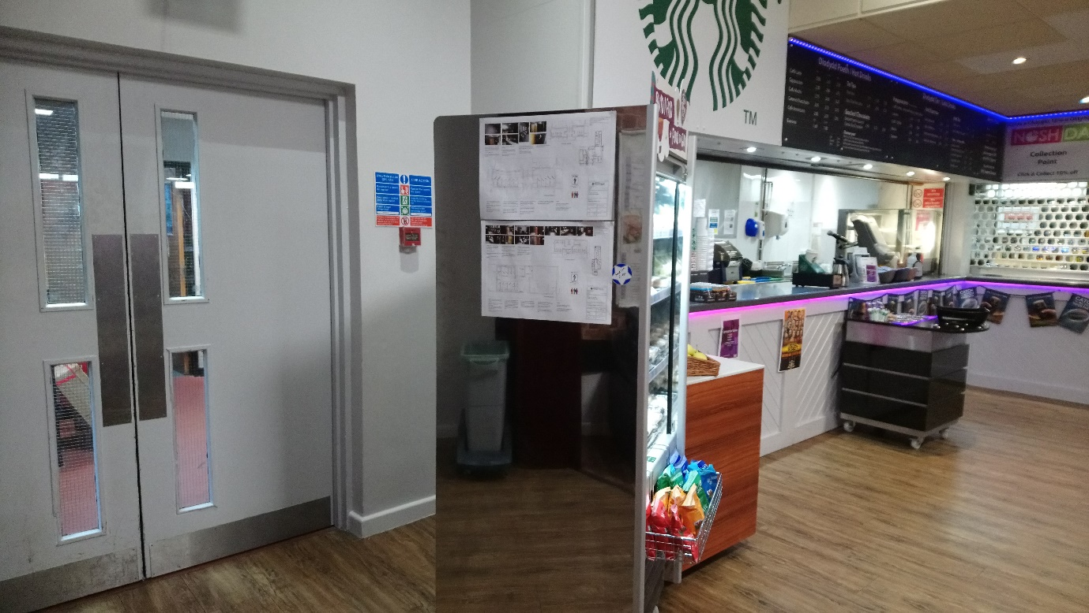
Figure 3 - Chiller obscuring fire exit
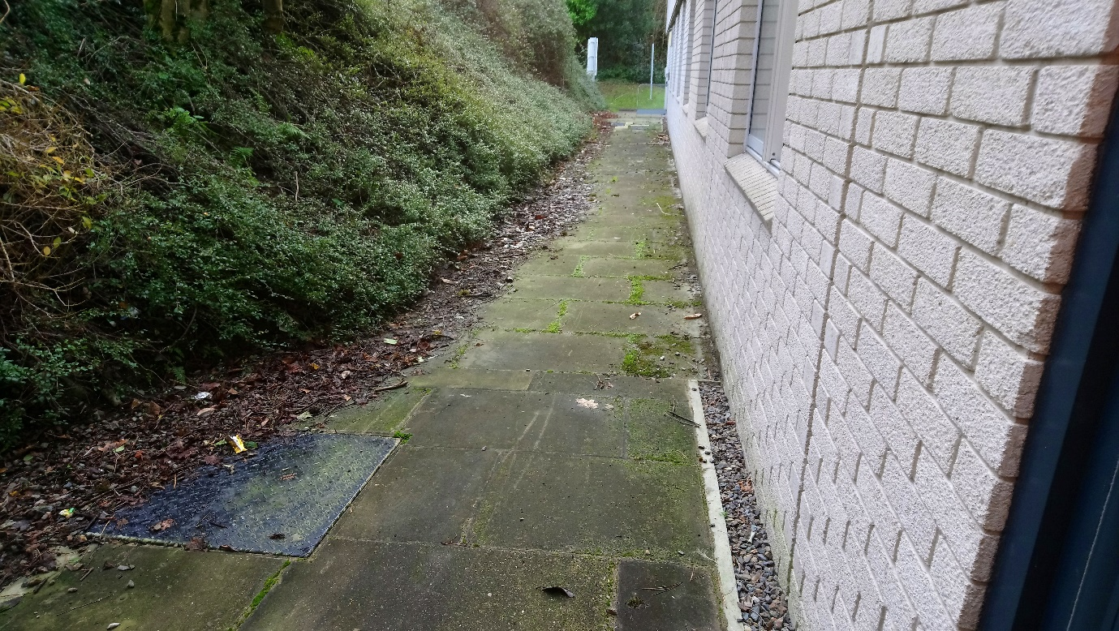
Figure 4 – Rear exit from lower ground floor due to leaves moss and other organic matter

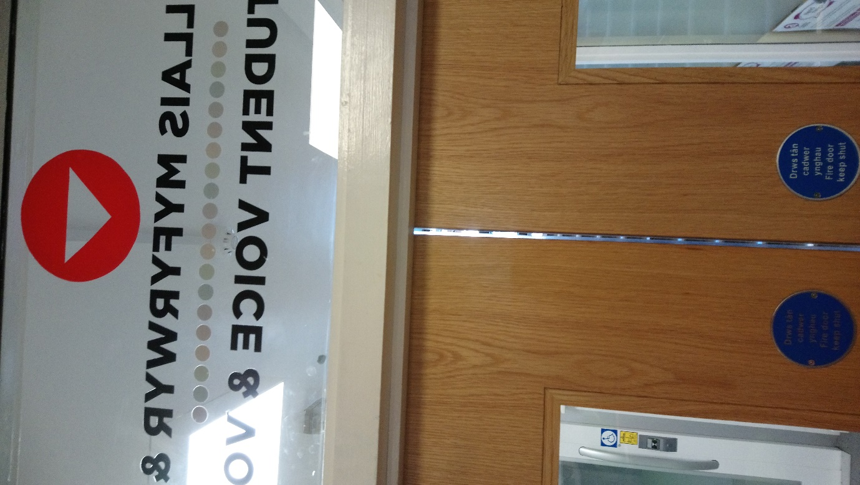
Figure 5 – Excessive gap between door leaves

