Aberystwyth Polling Stations for
Ceredigion General Election 2015
https://www.google.co.uk/maps/@52.400932,-4.0694413,18z
All polling stations for Aberystwyth are shown below by a star:
- St Pauls Methodist Centre, Queens Road
- Community Hall. Waunfawr
- Buarth Hall, Stanley Road
- St Padarn, Church Hall, Llanbadarn Fawr
- Silver Band Room, Park Avenue
If you’re in a University Halls of Residence, we have noted your polling stations below.
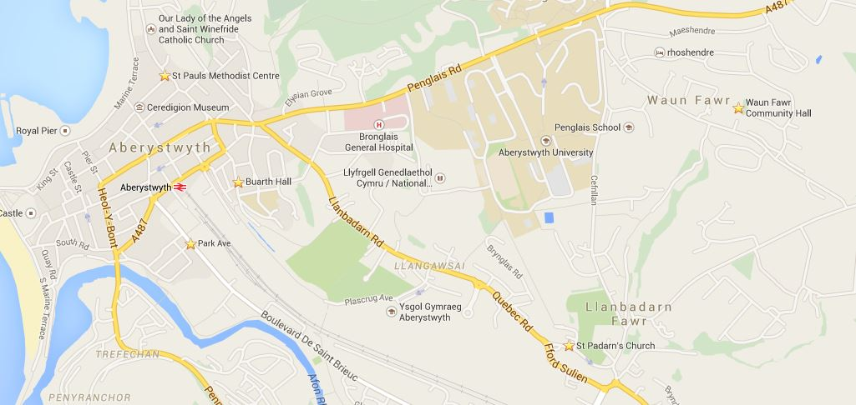

Only registered members can vote
Voting period is between 7am -10pm
If you have your polling card please take it with you. If you don’t have your polling card please take a form of ID.
If you don’t know where your polling station is, please contact Ceredigion Council on 01545572279.
Students’ Union minibuses will be leaving and visiting all polling stations:
Penbryn: 10:00, 10:30, 11:00, 11:30, 12,00
Pantycelyn: 10:00, 10:30, 11:00, 11:30, 12:00
Cwrt Mawr: 12:30, 13:00, 13:30, 14:00, 14:30, 15:00
Fferm Penglais: 12:30, 13:00, 13:30, 14:00, 14:30, 15:00
Students’ Union Steps: 15:30, 16:00, 16:30, 17:00
PENPARCAU MEMORIAL HALL
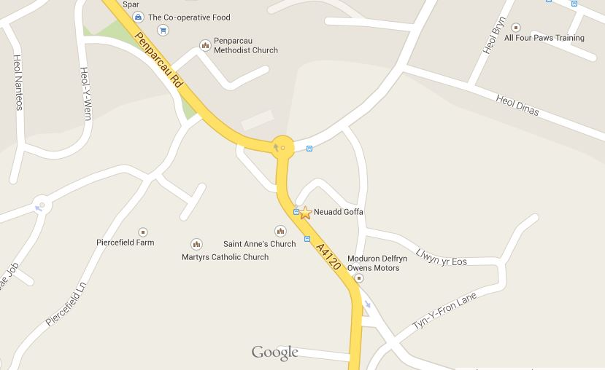

ST PAULS METHODIST CENTRE
Queens Road
Pentre Jane Morgan: 155-178 (excluding 161+162)
Victoria Terrace
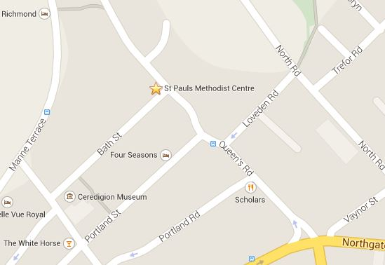

COMMUNITY HALL
Waunfawr
Pentre Jane Morgan: 1-154 + 161-162
Fferm Penglais
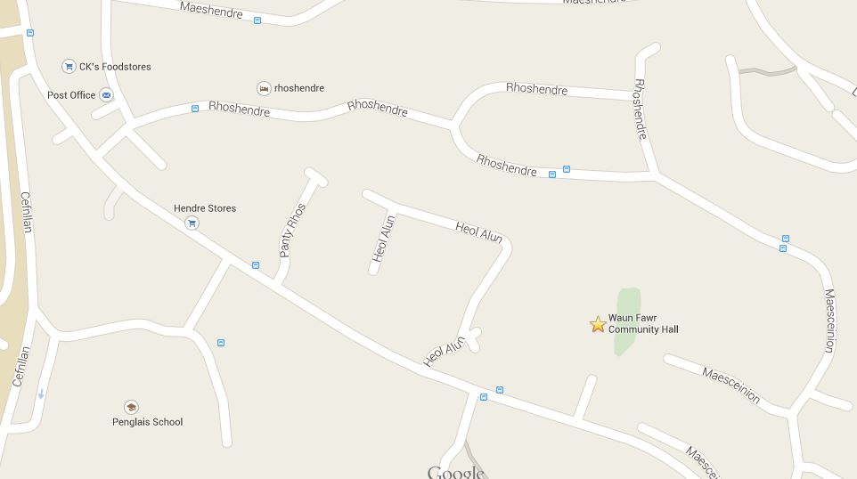

BUARTH HALL
Stanley Road
Neuadd Pantycelyn Hall
Neuadd Penbryn Hall
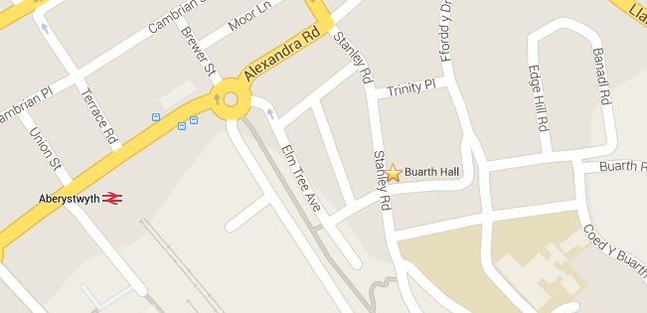

ST PADARN CHURCH HALL
Llanbadarn Fawr
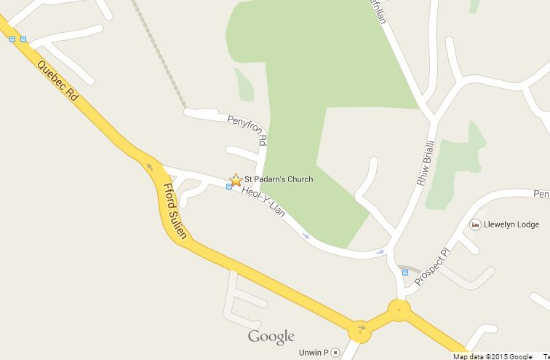
Neuadd Cwrt Mawr Hall
Neuadd Rosser Hall
Neuadd Trefloyne Hall

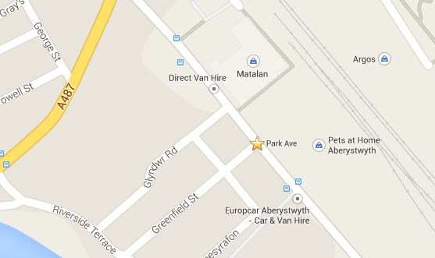
SILVER BAND ROOM
Park Avenue (behind Pets of Home)

